Computer Networks Lab Task – 8
Instructor: Ma’am Hurmat Hidayat
Roll No: 20P-0563
Name: Mahad Ashraf
Section: B

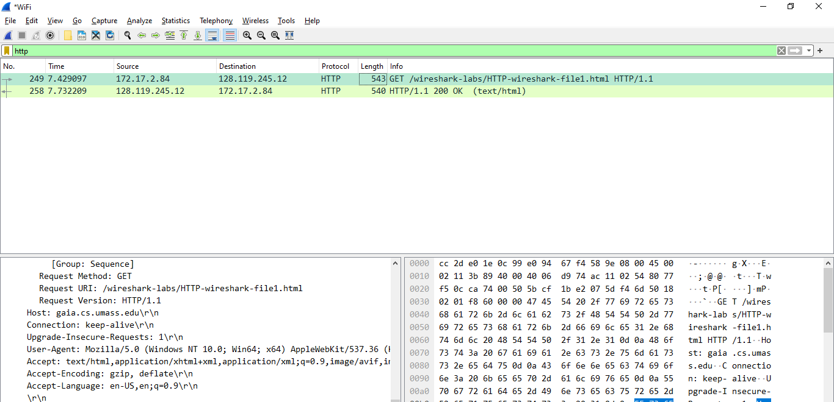



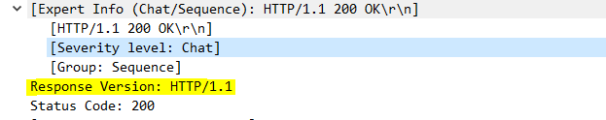

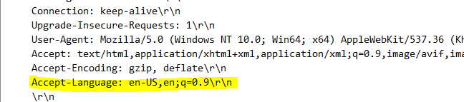

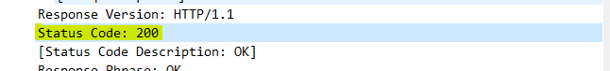

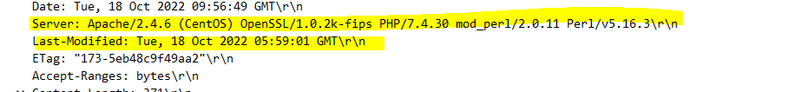



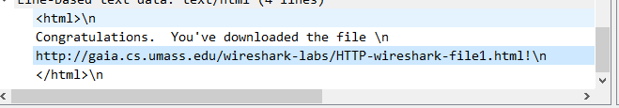
No, I do not see any headers in the http since they were missing .

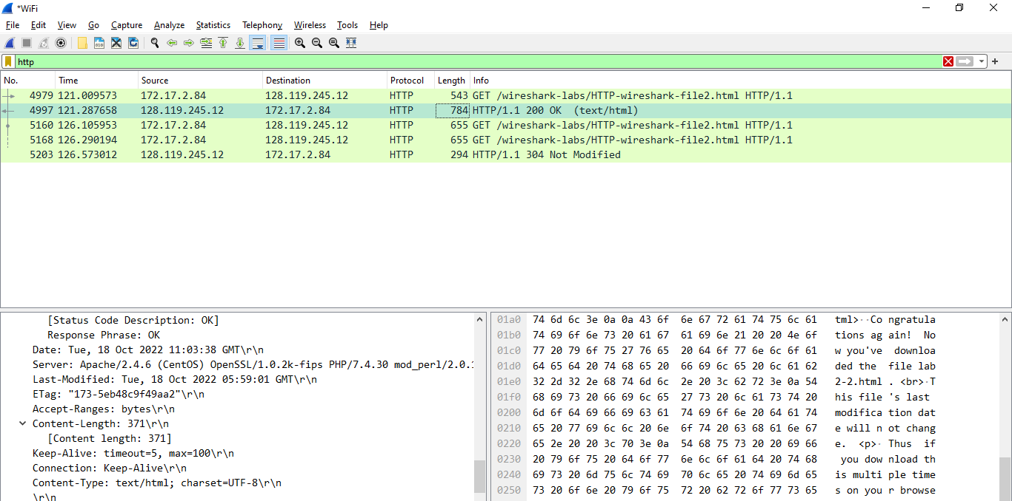


No there is no IF-MODIFIED-SINCE line in the GET message.

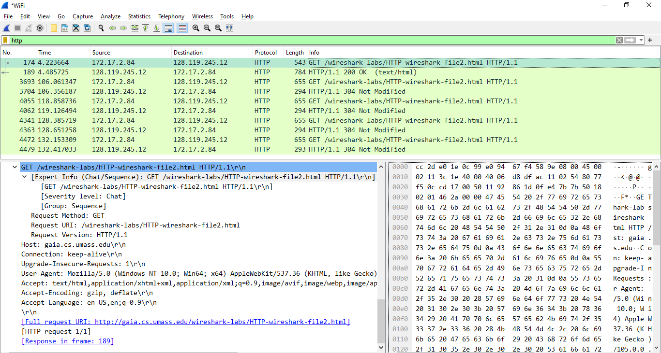

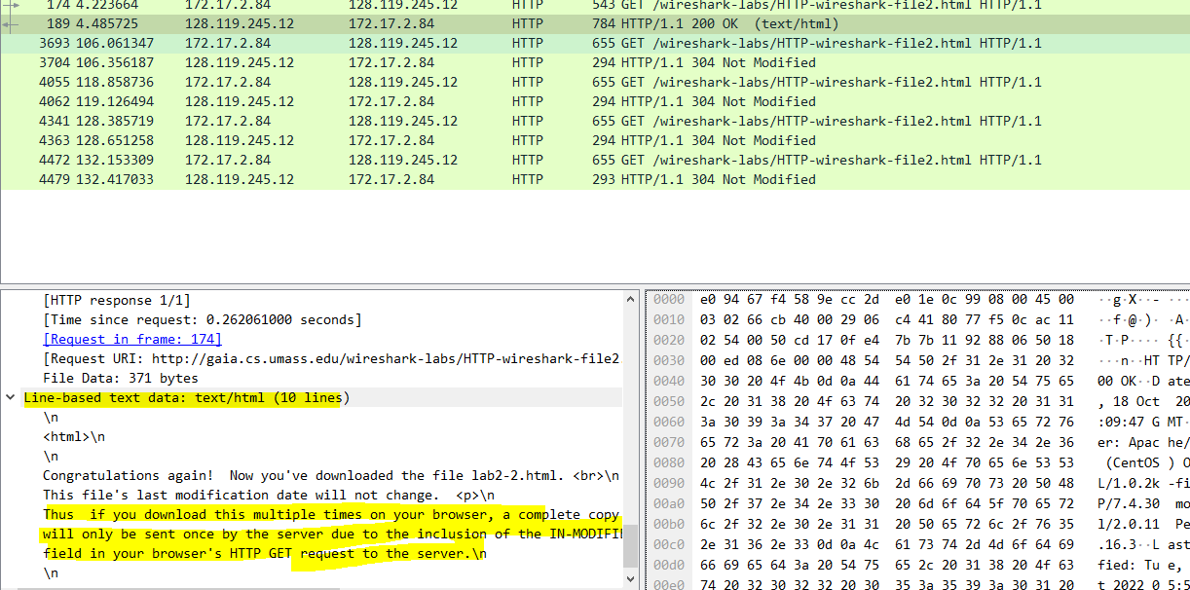

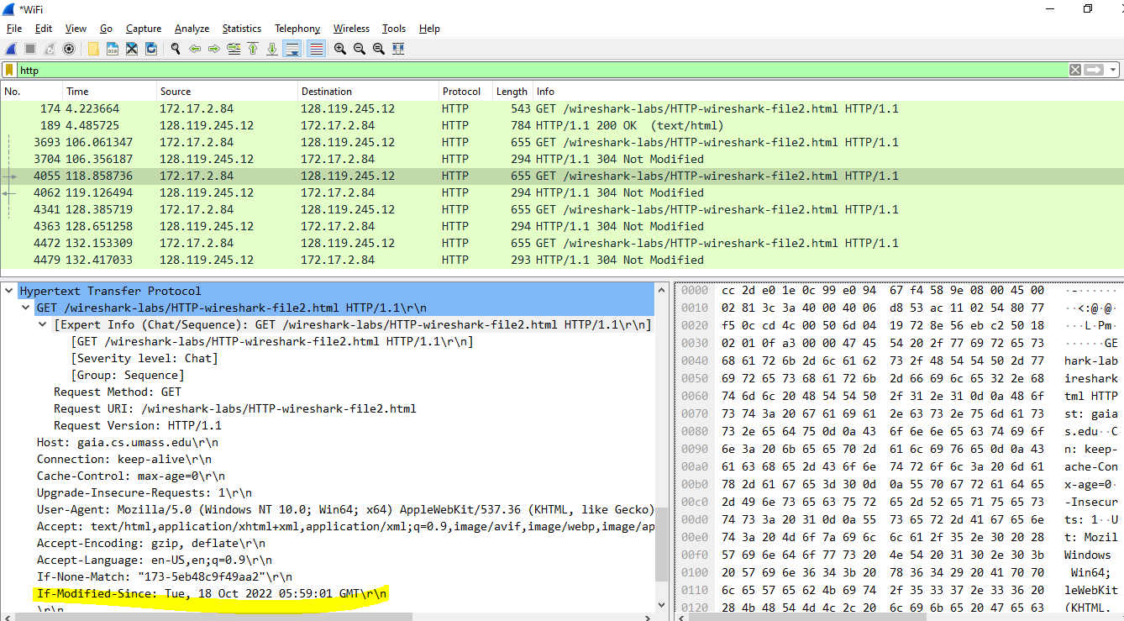

The HTTP status code is “304: Not Modified”
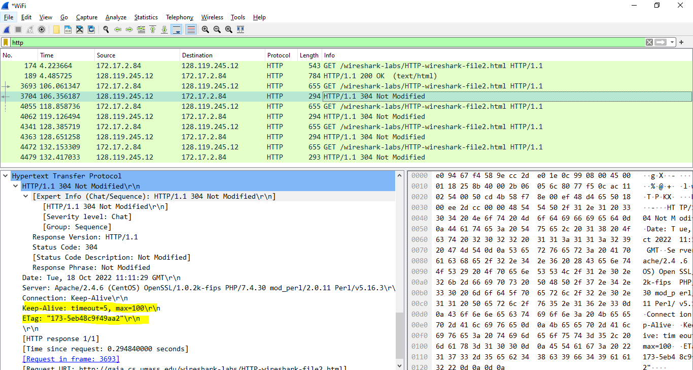
The server did not return the contents of the file because the browser simply retrieved the contents from its cache. Had the file been modified since it was last accessed, it would have returned the contents of the file, instead it simply told my browser to retrieve the old file from its cached memory.

